**Enhancement Functional Specification**

Leak Data Report for TIMP Annual Risk Analysis

CR# 108149642

CH# 108204595

VERSION: 1.1

LAST UPDATED: 06/17/2014

# DOCUMENT CONTROL:

## REVISION HISTORY:

|  |  |  |  |
| --- | --- | --- | --- |
| Version # | Date Modified | Modified By | Brief Description of Change |
| 1.0 | 06/10/2014 | Harisha Aswathnarayana(Hxax) | Initial document |
| 1.1 | 06/13/2014 | Harisha Aswathnarayana(Hxax) | Incorporated review comments from Junaid, Dalton & Nikola |
| 1.2 | 06/17/2014 | Harisha Aswathnarayana(Hxax) | Incorporated review comments from business team |
|  |  |  |  |
|  |  |  |  |

## APPROVALS:

|  |  |  |  |
| --- | --- | --- | --- |
| Author | Harisha Aswathnarayana(Hxax) | Date Created: | 06/13/2014 |
| Functional Team Lead | Junaid Manzoor (j9m9) | Signature and Date Approved: |  |
| Business Process Owner | Gordon Ye (GHY1) | Signature and Date Approved: |  |
| Technical Team Lead | Dalton Chan (DCCa) | Signature and Date Approved: |  |
| Project Manager | NA | Signature and Date Approved: |  |

TABLE OF CONTENTS:

I. DOCUMENT CONTROL: 2

A. REVISION HISTORY: 2

B. APPROVALS: 2

II. INTRODUCTION 4

A. Purpose of the document 4

B. Request Overview 4

III. OVERVIEW 5

A. Business Driver 5

B. Key business requirements 5

C. High level Process overview 5

D. Alternative Solutions evaluated 6

IV. DETAILS 7

A. Scope 7

B. Assumptions 7

C. Detail Processing Logic 7

D. Open Issues: 12

E. Exception Handling Rules 12

F. Special Requirements 12

G. Dependencies 12

H. Constraints 12

I. Scheduling Requirements 12

J. Test Specification 12

1. Functional Test Scenarios 12

2. Test Data & Other Needs 13

3. Test System & Environment 13

K. Audit Requirements/Integrity Controls 13

L. Security/Authorization Requirements 13

# INTRODUCTION

## Purpose of the document

The purpose of this document is to identify the requirements to design and develop a report on leak data from SAP into a csv file that will feed the Dynamic Risk Compliance Auditor tool for TIMP's annual Risk Analysis.

## Request Overview

1. Scenario ID: 108149642

2. Scenario Title: MARINER ASSET INTEGRITY-LEAK DATA 2 csv

3. Process ID:

4. Process Title:

5. Development Spec ID:

6. Name of Enhancement: Leak Data Report Program for TIMP annual Risk Analysis

7. Short Description: Design and development of enhancement to download Leak data report in .csv type

8. Type:  Function Exit / User Exit  Routines  SAP Code mod.

Custom program/transaction  Other_________________

9. Data latency: Real-time  Batch  On-demand

10. Frequency:  Annually  Quarterly Monthly  Weekly

Daily Other

11. Requesting Team: TIMP team

12. Systems Impacted:  R/3  CRM  APO  EBP  BW  SEM

Other____________

13. Modules Impacted:  FI  CO  SD  MM  PP  QM  BW  SEM PM/WM

Other____________

14. Complexity  High  Medium  Low

15. Spec Created on: 06/10/2014

16. Date required by: 07/10/2014

17. Created by: Harisha Aswathnarayana (Hxax)

18. Functional Analyst: Junaid Manzoor (j9m9)

19. Technical Analyst: Dalton Chan (DCCa)

20. Business Owner: Gordon Ye (GHY1)

# OVERVIEW

## Business Driver

To perform TIMP (Mariner Asset Integrity) annual Risk Analysis, Dynamic Risk Compliance Auditor tool needs to be updated with Leak data from SAP. This requires development of custom program to create a leak data report, Informatica will further process leak data from SAP and save information at ESFT site.

## Key business requirements

This design defines requirements for a new leak data report. The key business requirements are listed below:

1. Generate leak repair data report with 47 fields from SAP standard and custom tables.
2. Report program to be run in batch mode for previous month and manual execution for historical records. Output needs to be in a .csv format.
3. Place report generated in SAP Application server directory folder. ESFT to move the file & Informatica to read leak data using interface file structure.
4. Frequency of report generation is monthly for previous month report.
5. Generate report for historical leak records with option to input date range. For historical leaks (i.e, report executed based on user inputs) will be manual on need basis.
6. For Monthly reports; Automate the process of report generation and later feed leak data to Dynamic Risk Compliance Auditor tool for TIMP's annual Risk Analysis.

## High level Process overview

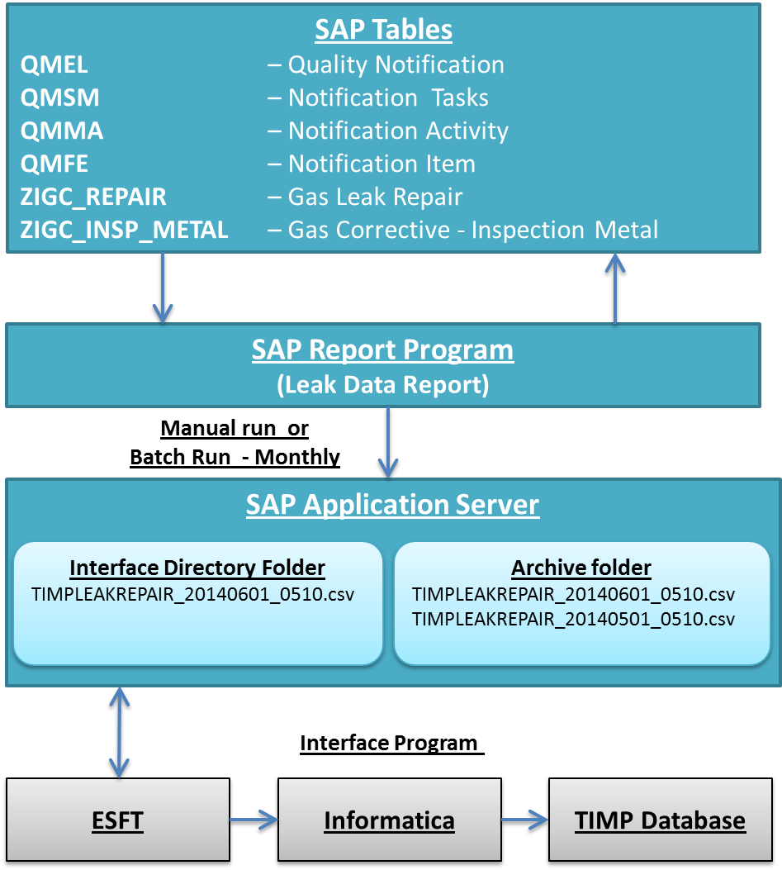

Figure 1 Leak Data Report Program – high level process overview

## Alternative Solutions evaluated

<Identify and document the alternative solutions evaluated and their reason for rejection.>

|  |  |  |  |
| --- | --- | --- | --- |
| No. | Alternatives | Evaluation | Reason for rejection  (Cost, Timeline, Change Impact, etc.) |
| 1 |  | Pros:  a.  b.  c. |  |
| Cons:  a.  b.  c. |
| 2 |  | Pros:  a.  b.  c. |  |
| Cons:  a.  b.  c. |

# DETAILS

## Scope

The scope of this design is to develop leak data report and place report output in SAP application server directory folder.

## Assumptions

Following assumptions are made in the design:

1. Leak data report scheduled monthly will be placed in SAP application server directory folder.
2. Report program is run in batch mode and output file type is .csv format
3. Data conversion & cleansing of historical leak records to SAP is out of scope.
4. Design and development activities involving file transfer from SAP application server directory folder to ESFT site is out of scope
5. Business team to provide DL to notify any batch job run failures in SAP. Re-run of failed batch jobs will be as per current process of SAP operations team (TSC request and approval process), business team needs to request for re-run of batch job.

## Detail Processing Logic

Detailed requirements and design specifications are covered in the following sections:

1. Input parameters for report will be Start date & End date of the previous month. Previous month Start date & End date are determined based on report execution date. Ex: Report executed on 06/01/2014 will consider Start date 05/01/2014 & End date 05/31/2014. Calendar dates will be considered for Start date & End date. Any new leaks created and leaks updated within Start date & End date will be reported in output file. This will hold good for below runs;
   1. Report run on first date of current month fetches records for previous month
   2. Report run on any date of current month fetches records for previous month
2. Frequency of report run will be monthly and on first date of calendar month. Run failures will be an exception and business team needs to request SAP operations team for a re-run.
3. Attached is the format and fields, on execution of Leak data report output file will be generated;

Leak repair report – output 47 fields

|  |  |  |  |  |
| --- | --- | --- | --- | --- |
| **Sl no** | **Field Name** | **SAP Table** | **Table description** | **SAP Field Name** |
| 1 | Notification No | (All) |  | QMNUM |
| 2 | Coating Condition | ZIGC_INSP_METAL | Gas Corrective - Inspection Metal | COATING_COND |
| 3 | Coating Type | ZIGC_INSP_METAL | Gas Corrective - Inspection Metal | COATING_TYPE |
| 4 | Cover on Pipe (inches) | ZIGC_INSP_METAL | Gas Corrective - Inspection Metal | COVER_ON_PIPE |
| 5 | External Gouging | ZIGC_INSP_METAL | Gas Corrective - Inspection Metal | EXTERN_GOUGE |
| 6 | External Pitting | ZIGC_INSP_METAL | Gas Corrective - Inspection Metal | EXTERN_PIT |
| 7 | External Pit Depth | ZIGC_INSP_METAL | Gas Corrective - Inspection Metal | EXTERN_PIT_DEPTH |
| 8 | External Rust | ZIGC_INSP_METAL | Gas Corrective - Inspection Metal | EXTERN_RUST |
| 9 | External Gouge Depth | ZIGC_INSP_METAL | Gas Corrective - Inspection Metal | GOUGE_DEPTH |
| 10 | Long Seam | ZIGC_INSP_METAL | Gas Corrective - Inspection Metal | LONG_SEAM |
| 11 | Soil Resist | ZIGC_INSP_METAL | Gas Corrective - Inspection Metal | SOIL_RESIST |
| 12 | Soil Type | ZIGC_INSP_METAL | Gas Corrective - Inspection Metal | SOIL_TYPE |
| 13 | Paved Wall to Wall | ZIGC_INSP_METAL | Gas Corrective - Inspection Metal | WALL2WALL |
| 14 | Wall Thickness | ZIGC_INSP_METAL | Gas Corrective - Inspection Metal | WALL_THICKNESS |
| 15 | Above Ground Indicator | ZIGC_REPAIR | Gas Leak Repair | ABOVE_BEL_GRND |
| 16 | Leak Location Block | ZIGC_REPAIR | Gas Leak Repair | BLOCK_MAP |
| 17 | Address | ZIGC_REPAIR | Gas Leak Repair | BUILDING |
| 18 | City | ZIGC_REPAIR | Gas Leak Repair | CITY |
| 19 | Federal Lands | ZIGC_REPAIR | Gas Leak Repair | FEDRL_LAND |
| 20 | Leak Source is HCA | ZIGC_REPAIR | Gas Leak Repair | HCA |
| 21 | Address | ZIGC_REPAIR | Gas Leak Repair | HOUSE_NUM |
| 22 | Repair Comments | ZIGC_REPAIR | Gas Leak Repair | INSTALL_COMMENTS |
| 23 | Latitude | ZIGC_REPAIR | Gas Leak Repair | LATITUDE2 |
| 24 | Cause Desc | ZIGC_REPAIR | Gas Leak Repair | LEAK_CAUSE_EXPL |
| 25 | Diameter | ZIGC_REPAIR | Gas Leak Repair | LINE_SIZE |
| 26 | Line Use | ZIGC_REPAIR | Gas Leak Repair | LINE_USE |
| 27 | Leak Location Plat | ZIGC_REPAIR | Gas Leak Repair | LOC_PLAT_MAP |
| 28 | Leak Location Map | ZIGC_REPAIR | Gas Leak Repair | LOC_WALL_MAP |
| 29 | Longitude | ZIGC_REPAIR | Gas Leak Repair | LONGITUDE2 |
| 30 | Tightened Lubricated Adjusted (i.e. non-OPS reportable) | ZIGC_REPAIR | Gas Leak Repair | MECH_JOINT |
| 31 | Mile Point | ZIGC_REPAIR | Gas Leak Repair | MILE_POINT |
| 32 | Orig Job No | ZIGC_REPAIR | Gas Leak Repair | ORIG_JOBNBR |
| 33 | Pipe to Soil | ZIGC_REPAIR | Gas Leak Repair | PIPE2SOIL |
| 34 | Route | ZIGC_REPAIR | Gas Leak Repair | PIPELINE_NBR |
| 35 | Repair Location Diff | ZIGC_REPAIR | Gas Leak Repair | REPAIR_LOC_DIFF |
| 36 | Repair Location | ZIGC_REPAIR | Gas Leak Repair | REPAIR_LOCATION |
| 37 | Repair Remarks | ZIGC_REPAIR | Gas Leak Repair | REPAIR_REMARKS |
| 38 | Response Date | ZIGC_REPAIR | Gas Leak Repair | RESPONSE_DATE |
| 39 | Address | ZIGC_REPAIR | Gas Leak Repair | STREET |
| 40 | Transmission Definition | ZIGC_REPAIR | Gas Leak Repair | SYSTEM_PRESSURE |
| 41 | Installation Date | ZIGC_REPAIR | Gas Leak Repair | YEAR_INSTALLED |
| 42 | Leak Cause | QMFE | Quality notification - items | FECOD |
| 43 | Leak Source | QMFE | Quality notification - items | OTEIL |
| 44 | Repair Method | QMMA | Quality notification - activities | MNCOD |
| 45 | Repair Date | QMSM | Quality notification - tasks | ERLDAT |
| 46 | Initial Grade | QMEL  (ZIWRE_LK_HISTORY) | Quality Notification | ZZIGIS_GRADE |
| 47 | Current Grade | QMEL  (ZIWRE_LK_HISTORY) | Quality Notification | ZZIGIS_GRADE |

Table 1 : Leak repair report field list



Table 2 Report layout

1. Data will be fetched from below tables;
   1. QMEL – Quality Notification
   2. QMSM – Notification Tasks
   3. QMMA – Notification Activity
   4. QMFE – Notification Item
   5. ZIGC_REPAIR – Gas Leak Repair
   6. ZIGC_INSP_METAL – Gas Corrective - Inspection Metal
2. A custom ABAP program will be developed for leak data report which can be run in batch mode for monthly report and using a transaction code for manual execution on need basis.
3. Processing logic for new leaks reported & changed for previous month

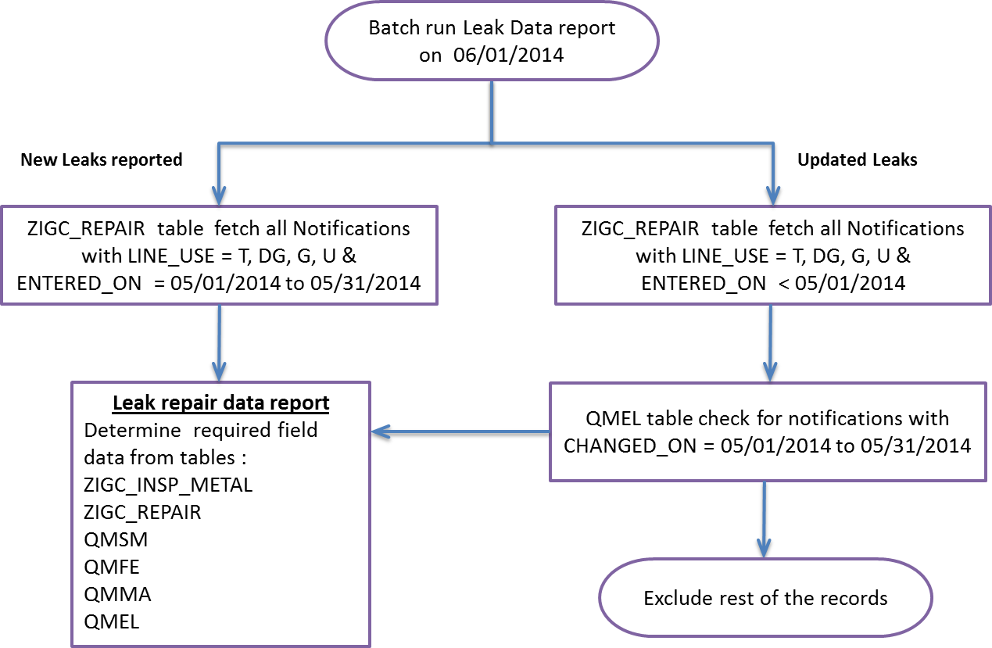

Figure 2 Processing logic for Batch run – Leak data report for previous month

1. Fetch all notifications from table ZIGC_REPAIR - Gas Leak Repair with LINE_USE = T, DG, G, U & ENTERED_ON between 05/01/2014 to 05/31/2014
2. For all these notifications; Using Notification number continue with tables ZIGC_INSP_METAL, ZIGC_REPAIR, QMSM, QMFE, QMMA & QMEL to fetch corresponding field values to generate leak repair data report.
3. Fetch all notifications from table ZIGC_REPAIR - Gas Leak Repair with LINE_USE = T, DG, G, U & ENTERED_ON less than 05/01/2014
4. QMEL table check for notifications with CHANGED_ON between 05/01/2014 to 05/31/2014
5. For all these notifications; Using Notification number continue with tables ZIGC_INSP_METAL, ZIGC_REPAIR, QMSM, QMFE, QMMA & QMEL to fetch corresponding field values to generate leak repair data report.
6. Exclude rest of the notification records from processing.
7. Use program (Function module) ZIWRE_LK_HISTORY to derive Initial Leak Grade and Current Leak. Leak was detected and recorded; this will be the Initial leak grade. Leak grade value before repair activity is performed will be Current leak grade. Below is an example:

|  |  |  |
| --- | --- | --- |
| Activity | Date | Leak Grade |
| Leak detected | 05/07/2010 | 3 |
| Recheck Leak and correct grade | 02/03/2014 | 2 |
| Repair Date and register grade | 02/20/2014 | 0 |

Initial Grade value = 3 & Current Grade value = 2

1. Processing logic for fetching leaks reported and repaired based on date range (historical leaks)
2. Any leaks reported and repaired beyond the previous month are considered as historical leaks. Example: Current month 06/2014 leaks reported or repaired beyond 05/2014 are historical leaks.
3. Custom transaction with below selection screen will be developed.

* Date range will be mandatory.
* Line use will be a multiple selection field and will be optional.
* File path will be defaulted to SAP application server interface directory path. This will be read-only field.
* Upon execution; Leak repair data report and Leak grade data report will be stored in interface directory and archive folders

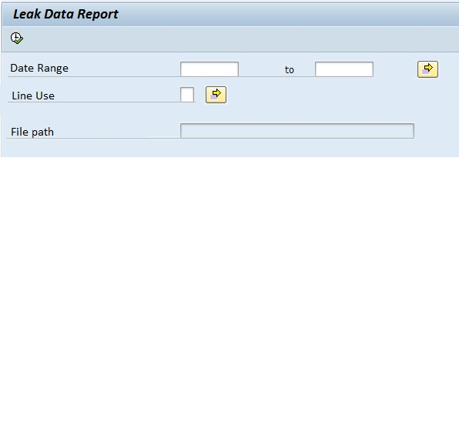

Figure 3 Indicative selection screen – Leak data report for historical leaks

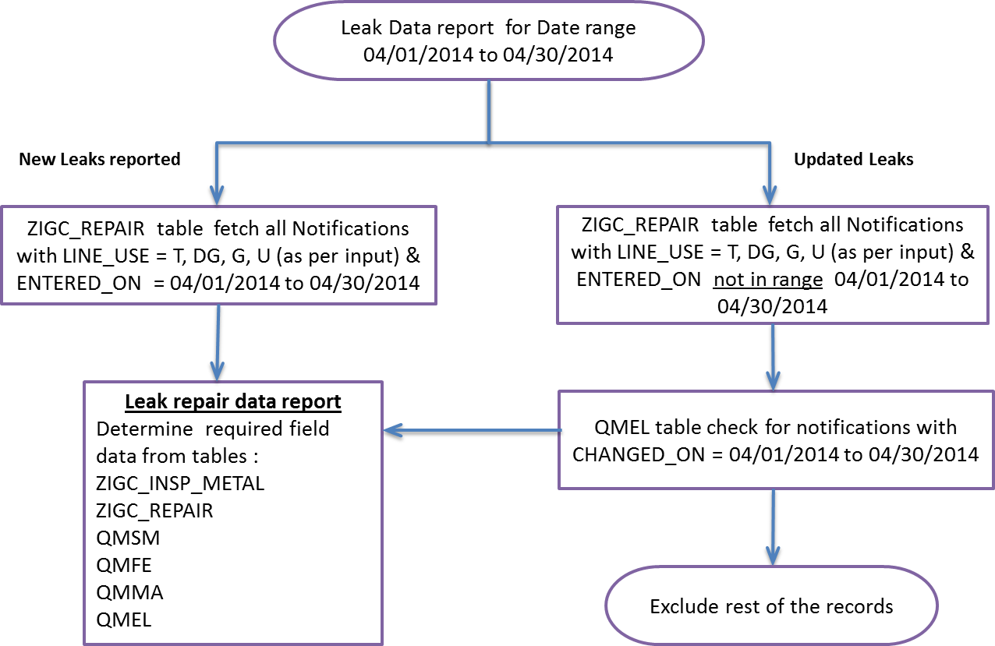

Figure 4 Processing logic for historical leaks – Leak data report

1. Leak Data report selection screen input Date range 04/01/2014 to 04/30/2014
2. ZIGC_REPAIR table fetch all Notifications with LINE_USE = T, DG, G, U & ENTERED_ON = 04/01/2014 to 04/30/2014
3. For all these notifications; Using Notification number continue with tables ZIGC_INSP_METAL, ZIGC_REPAIR, QMSM, QMFE, QMMA & QMEL to fetch corresponding field values to generate leak repair data report.
4. ZIGC_REPAIR table fetch all Notifications with LINE_USE = T, DG, G, U & ENTERED_ON not in range 04/01/2014 to 04/30/2014
5. QMEL table check for notifications with CHANGED_ON = 04/01/2014 to 04/30/2014
6. For all these notifications; Using Notification number continue with tables ZIGC_INSP_METAL, ZIGC_REPAIR, QMSM, QMFE, QMMA * QMEL to fetch corresponding field values to generate leak repair data report.
7. Exclude rest of the notification records from processing.
8. Output file is generated on successful execution of Leak data report will be .csv format
9. Output file generated will follow the below naming convention (YYYYMMDD will be the report run year, month and date & HHMM will be run hour and minute);
   1. Leak data repair report – TIMPLEAKREPAIR_YYYYMMDD_HHMM
10. On successful report run, output files will be placed in below folders of SAP application server;
    1. Interface directory folder – Folder to be refreshed upon file export to ESFT
    2. Archive folder – Folder to be refreshed based on retention period of SAP basis/operations team (90 days etc.)
11. SAP IT WM team will request SAP Basis team for creation of Interface directory and use existing Archive folder in Development, Quality & Production systems. SAP server credentials and folder details will be shared with Informatica and business teams.
12. In case of any unsuccessful run failures or folder creation failures, leak data report program needs to be re-run.
13. Notification Email will be triggered on any batch job failures to DL provided by business team.
14. Application log will be maintained for all executions of leak data report. This will be useful to validate for success and failure of report execution. Application logs availability will be based on SAP IT WM retention period.
15. ESFT & Informatica will further process leak data in .csv format stored in SAP application server using an interface file structure and save information at ESFT site.

## Open Issues:

## Exception Handling Rules

<Specify instructions to be followed when errors occur, or any processing outside the normal process flow.>

## Special Requirements

<Provide any special requirements related to this development effort such as language translations, configurability or personalization allowed, etc.>

## Dependencies

<List any dependencies to other technical objects or configuration objects>

## Constraints

<Discuss all the constraints or the limitations if any for this technical object>

## Scheduling Requirements

1. Report run mode: Batch
2. Frequency: Monthly
3. Date & Time: First day of calendar month at 5 am
4. New role will be created with privileges to execute Leak data report.
5. New Batch user id will be created to run Leak data report in background

## Test Specification

<This portion of the document is used to plan the unit testing. It includes items such as defining the test participants, the test environment, the schedule, and scope of the testing event.>

### Functional Test Scenarios

|  |  |  |
| --- | --- | --- |
| **Test Scenario** | **Expected Results** | **Comments** |
| Report output field list, file type | Field list and file type as expected |  |
| Setup batch job for Leak data report and schedule in background | Batch job run is successful and leak data file is created |  |
| Check for data consistency | Leak data file generated are validated for data consistency |  |
| Schedule batch job run on weekend (Sat & Sun), holiday as per PG&E calendar | Batch job run is successful |  |
| Historical leaks – Access custom transaction code and perform field level validations | Fields level validations are as expected |  |
| Execute report for date range beyond previous months | Leak data file generated is validated for data consistency |  |
|  |  |  |
|  |  |  |
|  |  |  |

### Test Data & Other Needs

<If any, specify test data set-up & refresh needs, volume of data, timeliness of data, etc.>

### Test System & Environment

<Identify test system and client.>

|  |  |
| --- | --- |
| Test System: | QA8 |
| Client: | 820 |

## Audit Requirements/Integrity Controls

<Specify the controls that are required to ensure that the data has been processed correctly.>

## Security/Authorization Requirements

<Provide any special authorization checking or data security provisions required.>

There are no special authorization requirements for entering of calibration information.